LAB 12: Datasources

Q-1 A data source once created, can be used to create, update, and destroy infrastructure?
True or False?
A-1 False , Bcz, We can only reads the attributes of resouce.

Q-2 A data source can be created using the data block.
True or False?
A-2 True.

Q-3
A new configuration directory has been created at /root/terraform-projects/project-lexcorp. A data source block is defined in the main.tf file to read the contents of an existing file.
There is also an output variable that uses reference expression to print the file content using this data source. However, there is something wrong!
Troubleshoot and fix the issue.
When ready, run terraform init, plan and apply to create the datasource. The configuration should print the output variable correctly.
A-3
BEFORE
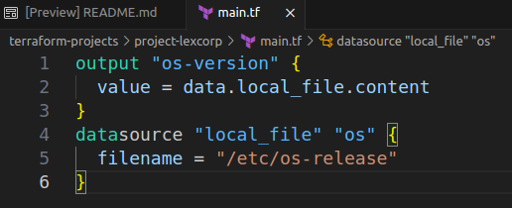
Look Data block are written Right ?
No.
Look Reference Expression in ouput block is Right ? No.
AFTER
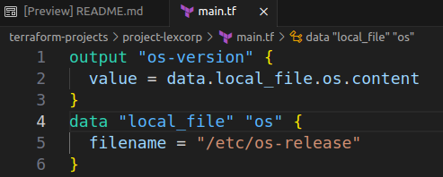

Q-4
Now let's practice how to work with data sources from other providers.
The next few questions will be based on the aws provider.
Although we have only predominantly worked with local and the random provider, this exercise will help you learn how to work with different data sources using the documentation.
Don't worry if the configuration blocks and the arguments are unfamiliar. We will cover them in detail in the upcoming section.
A-4 OK

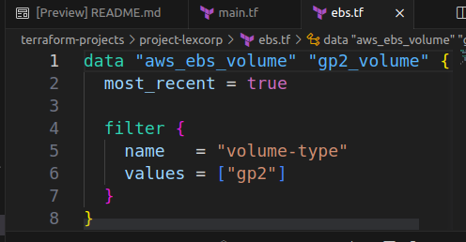
Q-5 We have now created a new configuration file called ebs.tf within the same configuration directory we have been working on.
What is the resource type that we are working with here?

A-5 aws_ebs_volume

Q-6 Once this data source is created, how do we fetch the Volume Id for the resource that is created in AWS?
You may have to look up the documentation for this one. Documentation tab is available at the top right.
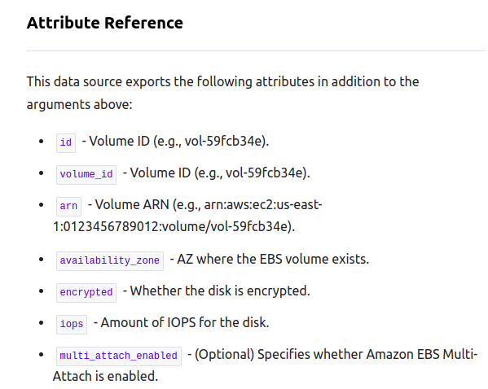
A-6 Refer Terraorm docs for ebs_volume
Find attributes

Ans is volume_id

Q-7
Another file called s3.tf has now been created. It too has a data source that will be used to read data of an existing s3 bucket.
However, there is a mistake in the argument used. What is wrong here?
You may have to look up the documentation for this one. Documentation tab is available at the top right.

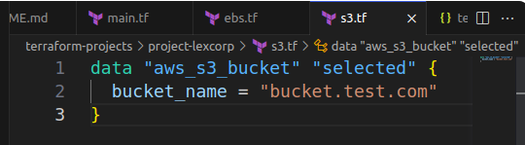
A-7 bucke_name is not valid argument

Refer Terraform docs for S3 Bucket.
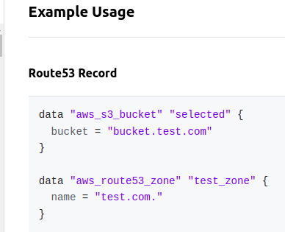

Here, bucket_name is not valid argument in data block.

Std formate is bucket = “bucket.test.com”

